Introduction

This document explains how to perform IAM tasks in AWS step by step with explanation.
IAM (Identity and Access Management) is used to securely control access to AWS services and resources.

Purpose of this assignment:
• Create IAM users
• Create IAM Group
• Assign permissions using policies and groups
• Automate using bash scripts
• Create custom policies
• Configure cross‑account access

Task 1: Create IAM User with EC2 and S3 Full Access

Step 1: Login to AWS Console
Explanation:
Login to AWS using root or admin account to create IAM users.

Step 2: Open IAM Service
Explanation:
IAM is used to manage users, groups, and permissions.

Step 3: Create new user named dev-user
Explanation:
IAM user represents a person or application that needs access.

Step 4: Enable console access
Explanation:
This allows user to login to AWS dashboard.

Step 5: Attach policies AmazonEC2FullAccess and AmazonS3FullAccess
Explanation:
Policies define permissions.
AmazonEC2FullAccess → full control over EC2
AmazonS3FullAccess → full control over S3

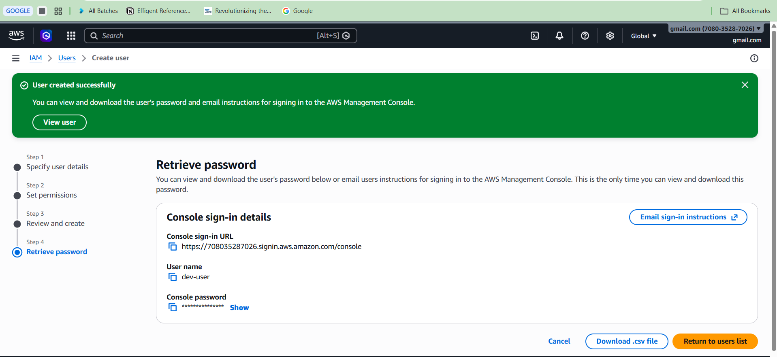

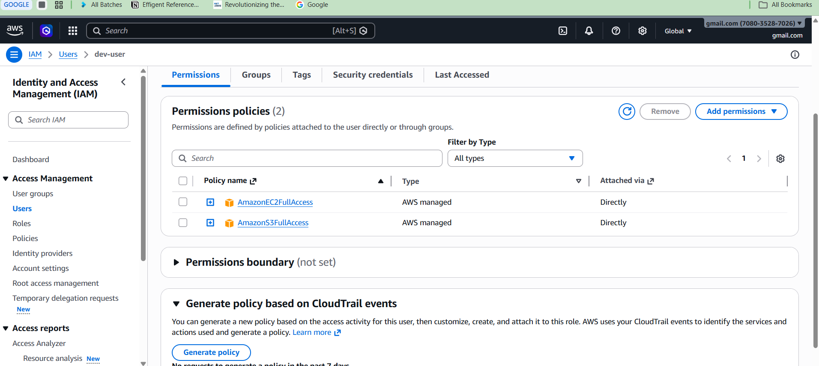

Task 2: Create IAM Group with EC2 Read Only Access

Step 1: Create group EC2-Read-Group
Explanation:
Group is used to manage multiple users with same permissions.
Step 2: Attach policy AmazonEC2ReadOnlyAccess
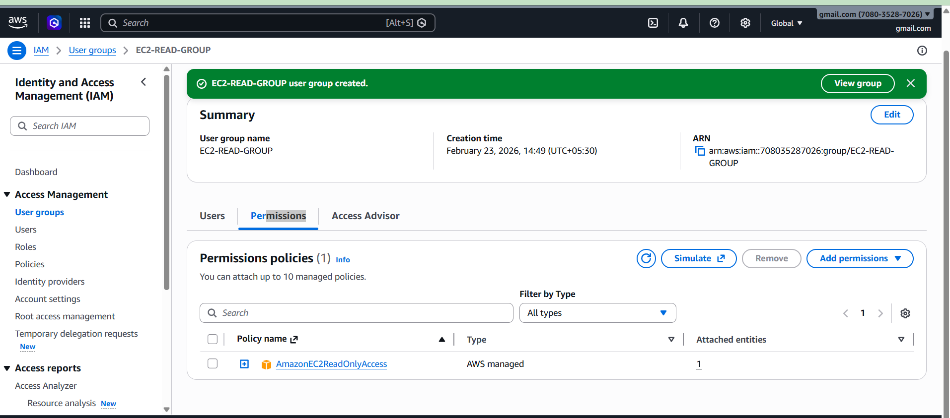
Explanation:
This allows viewing EC2 but not modifying.

Task 3: Create Devops User and Add to Group

Step 1: Create user Devops
Explanation:
Represents DevOps engineer.
Step 2: Add user to EC2-Read-Group
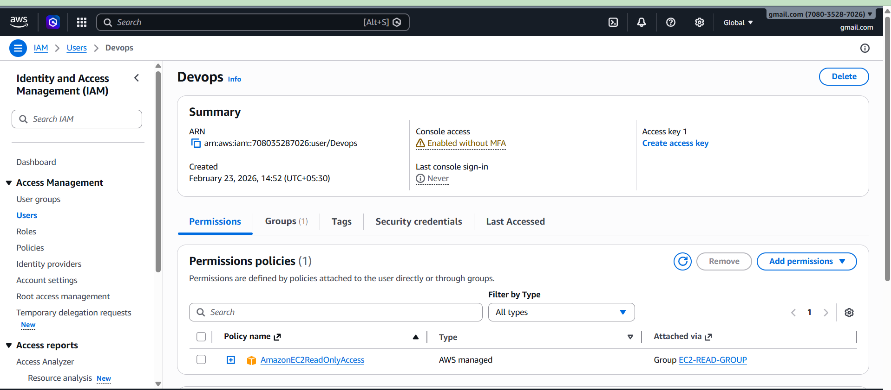

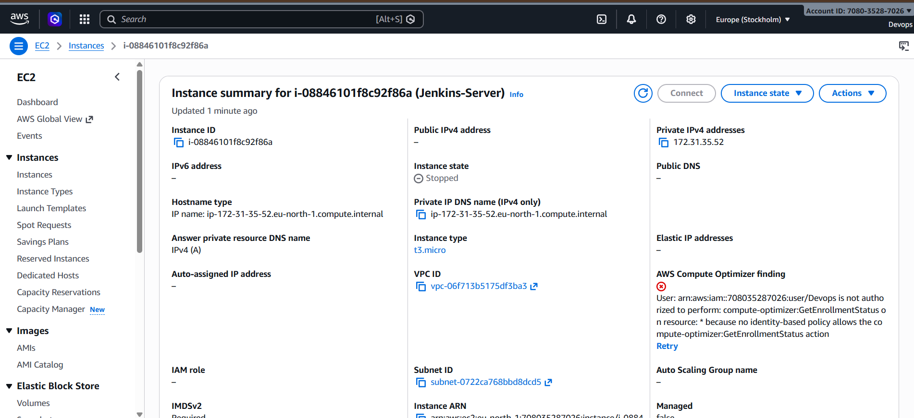
Explanation:
User inherits permissions from group automatically.

Task 4: Bash Script to Create IAM User with VPC Access

Step 1: Create bash script file
Explanation:
Bash script automates repetitive tasks.

Step 2: Use aws iam create-user command
Explanation:
Creates IAM user automatically.

Step 3: Attach AmazonVPCFullAccess policy
Explanation:
Provides full access to VPC service.
Step 4: Run script
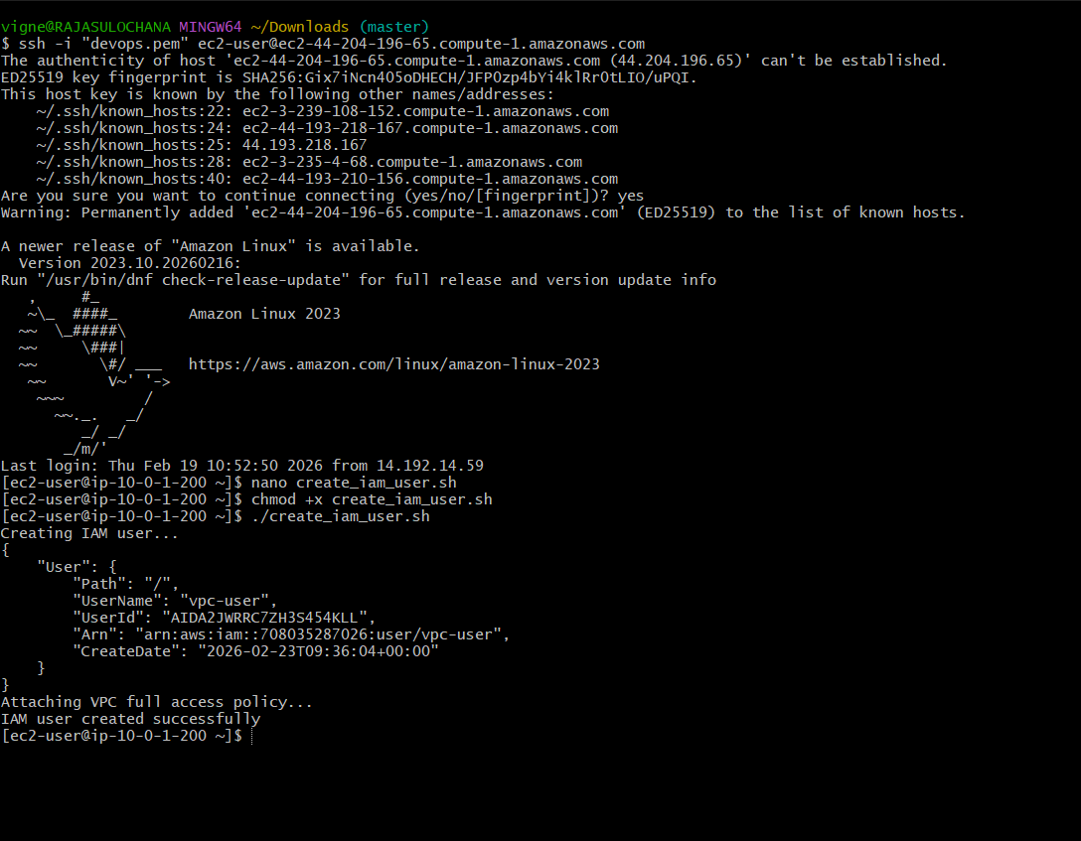
Explanation: Script executes commands automatically.

Task 5: Create Custom Policy for Specific Region

Step 1: Create new policy using JSON
Explanation:
JSON defines permissions.

Step 2: Restrict region using condition
Explanation:
Allows access only in specific AWS region.

Step 3: Attach policy to user
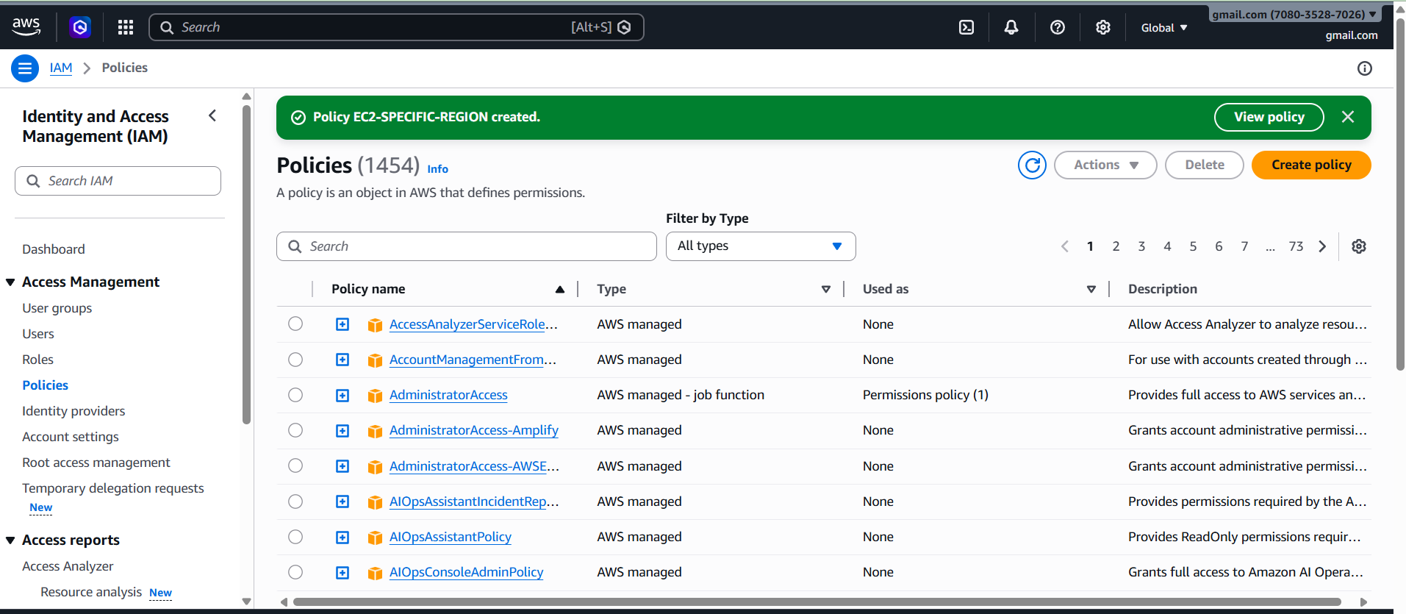

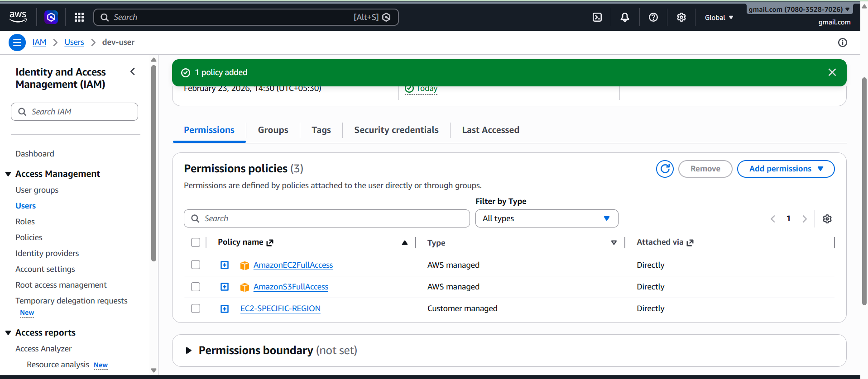
Explanation:
User now can access EC2 only in allowed region.

Task 6: Cross Account S3 Access
1. Overview
Cross-account role assumption allows one AWS account (Source Account) to access resources in another AWS account (Target Account) securely using IAM roles and temporary credentials.
Example:
Source Account ID: 127521539590
Target Account ID: 708035287026
Role Name: friend-s3-access
Purpose:
This is used when you want to give secure access between different AWS accounts without sharing permanent credentials.
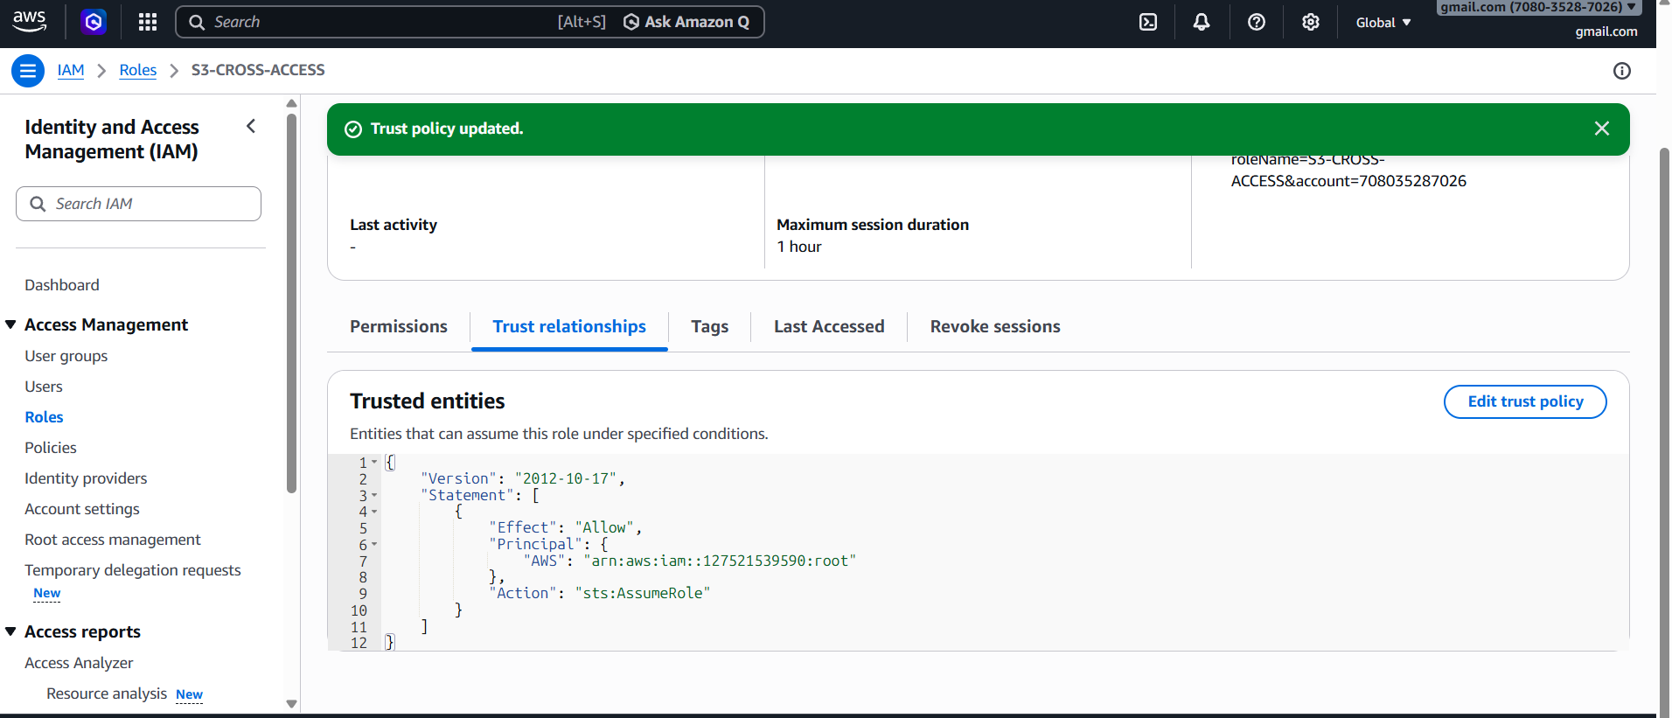
2. Key Components
Source Account:
The account that wants access.
Target Account:
The account that owns the resources.
IAM Role:
Created in Target Account. This role contains permissions (example: S3 access).
Trust Policy:
Defines WHO can assume the role.
Permission Policy:
Defines WHAT actions are allowed.
STS (Security Token Service):
Generates temporary credentials.
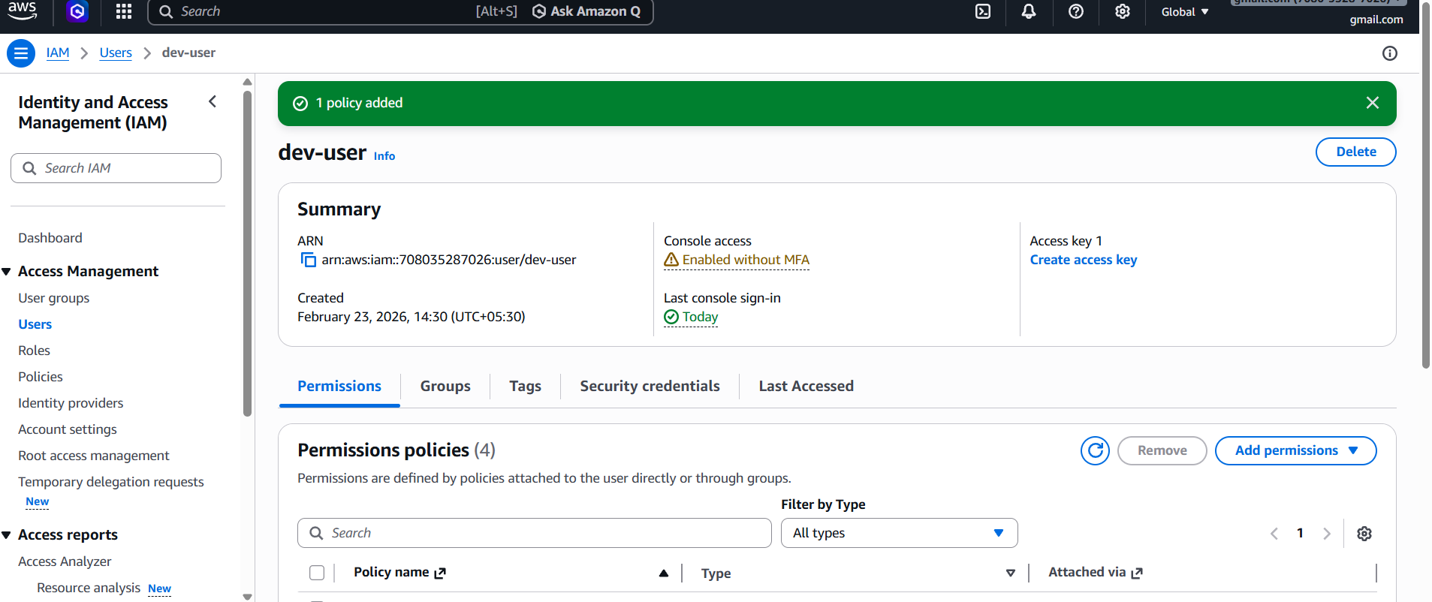

3. Step 1: Create Role in Target Account
Go to:
AWS Console → IAM → Roles → Create Role
Select:
Trusted Entity Type → AWS Account
Enter Source Account ID:
127521539590
Attach permissions:
Example: AmazonS3FullAccess
Role Name:
friend-s3-access
Click Create Role
4. Step 2: Configure Trust Policy
Go to:
IAM → Roles → friend-s3-access → Trust Relationships → Edit
Add:
{
"Version": "2012-10-17",
"Statement": [
{
"Effect": "Allow",
"Principal": {
"AWS": "arn:aws:iam::127521539590:root"
},
"Action": "sts:AssumeRole"
}
]
}
This allows Source Account to assume the role.
5. Step 3: Add Permission in Source Account
Go to:
IAM → Users → Select user → Add Inline Policy
Add:
{
"Version": "2012-10-17",
"Statement": [
{
"Effect": "Allow",
"Action": "sts:AssumeRole",
"Resource": "arn:aws:iam::708035287026:role/friend-s3-access"
}
]
}
This allows user to assume the target role.
------------------------------------------------------------
6. Step 4: Assume Role using AWS CLI
Command:
aws sts assume-role \
--role-arn arn:aws:iam::708035287026:role/friend-s3-access \
--role-session-name test
This generates temporary credentials.
------------------------------------------------------------
7. Step 5: Export Temporary Credentials
export AWS_ACCESS_KEY_ID=XXXX
export AWS_SECRET_ACCESS_KEY=XXXX
export AWS_SESSION_TOKEN=XXXX
8. Step 6: Verify Access
aws sts get-caller-identity
Output should show Target Account ID.

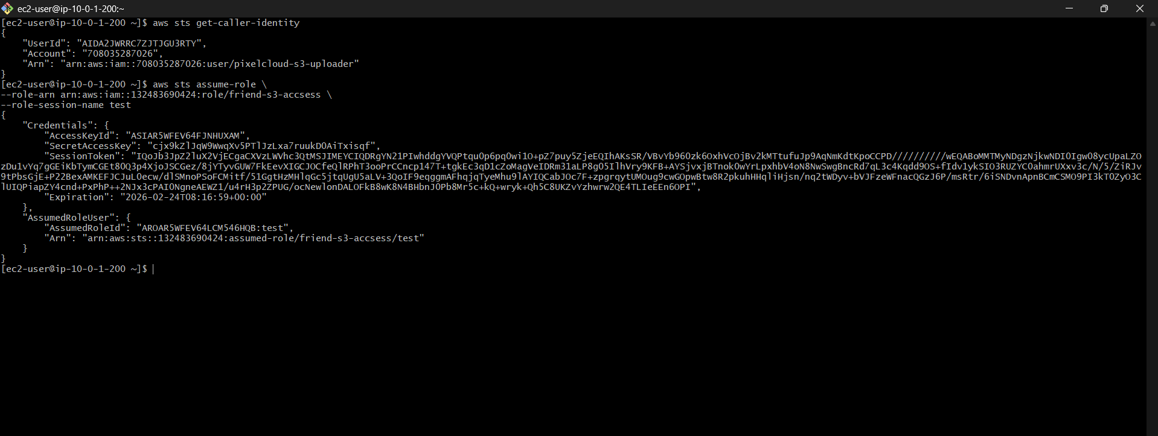
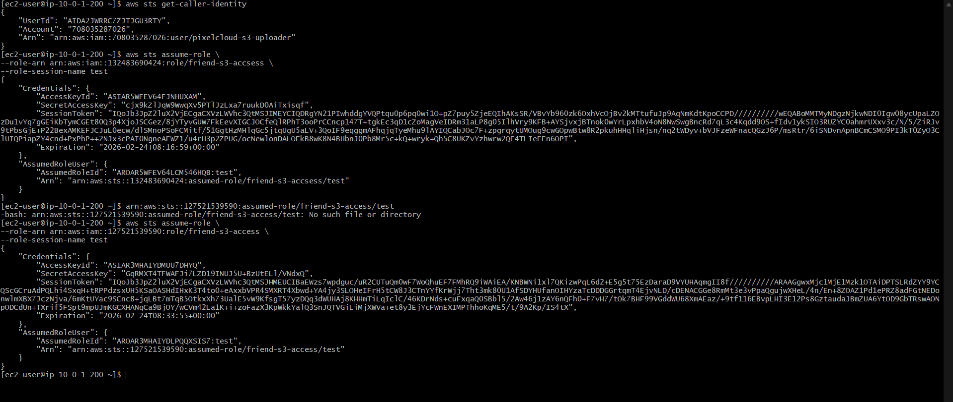

Result:
User in Account A can access S3 bucket in Account B.
1) Common Errors
Access Denied:
Missing trust policy or permission policy
Invalid Credentials:
Wrong export of temporary credentials
------------------------------------------------------------
2). Security Advantage
No need to share permanent credentials
Uses temporary credentials
More secure access control

Conclusion
• IAM user creation
• Group management
• Policy management
• Automation using bash
• Custom policies
• Cross account access

